**international communications**

**30-day media report – Research article**

**Original paper:** Behavioral regulation and approaches to learning: Moderators of the association between extracurricular involvement and academic readiness

**Journal:** Journal of School Psychology

**Authors:** Lixin Ren, Huiping Wu, Jieqiong Fan, Lin Li

**Date Published:** 4 October 2023

**DOI:** <https://doi.org/10.1016/j.jsp.2023.101250>

**Title of press release:** https://doi.org/10.1016/j.jsp.2023.101250

**Date Published:** 15 November 2023

**URL:** <https://www.xjtlu.edu.cn/en/news/2023/11/do-extracurricular-activities-always-give-children-a-head-start>

**Total number of unique readers of the media outlets that picked up the media release per month:**

**8,831,524**

**Number of views of media release per site where it was uploaded:**

|  |  |  |
| --- | --- | --- |
| Website | Views | Social media shares |
| ScienceX | 3300 | 18 |
| EurekAlert | 490 | n/a |
| Alpha Galileo | 123 (journalists) | n/a |

**Number of media outlets that picked up the media release (excluding Chinese outlets):**

6

**Languages the article has been translated into (not including Chinese):**

**Indonesian**

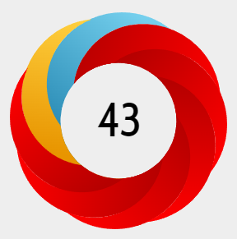**Altmetric score**

**In the top 4% of all research outputs scored by Altmetric.**

The Altmetric Attention Score for a research output provides an indicator of the amount of attention that it has received. The score is derived from an automated algorithm, and represents a weighted count of the amount of attention we've picked up for a research output.

Thanks for your support and we look forward to working with you again!

The International Communications Team